P Sai Koushik
2200032991
JUNIT TESTING
EXERCISE -4
Arrange-Act-Assert (AAA) Pattern, Test Fixtures, Setup and Teardown Methods in JUnit

OUT PUT
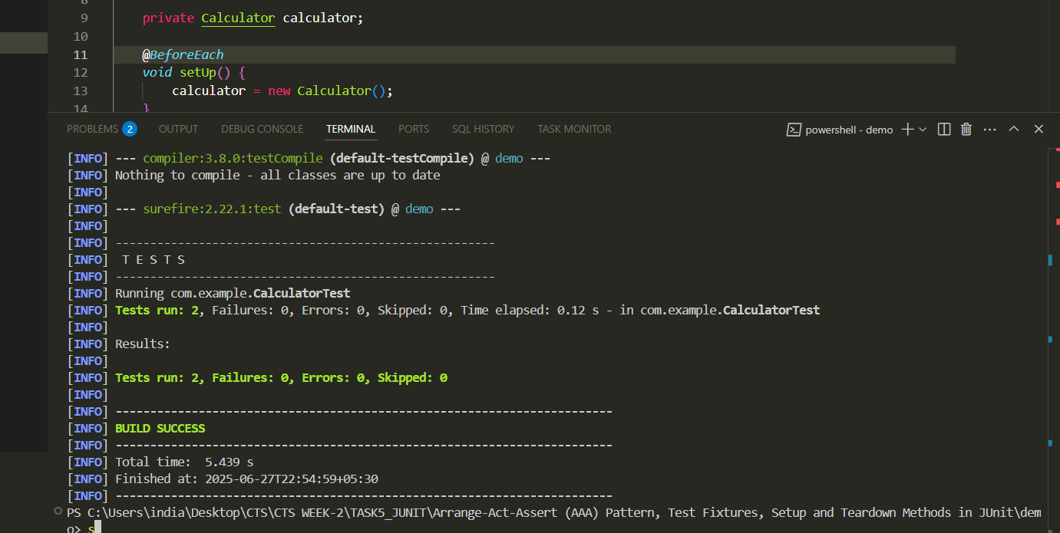

Files format
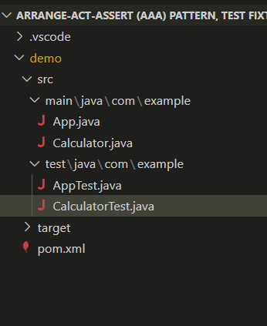

Calculator.java
package com.example;

public class Calculator {
public int add(int a, int b) {
return a + b;
}

public int subtract(int a, int b) {
return a - b;
}
}

calculatorTest.java
package com.example;

import org.junit.jupiter.api.*;

import static org.junit.jupiter.api.Assertions.*;

public class CalculatorTest {

private Calculator calculator;

@BeforeEach
void setUp() {
calculator = new Calculator();
}

@AfterEach
void tearDown() {
calculator = null;
}

@Test
void testAddition() {
int result = calculator.add(2, 3);
assertEquals(5, result);
}

@Test
void testSubtraction() {
int result = calculator.subtract(10, 4);
assertEquals(6, result);
}
}

